Dr. Ambedkar College, Deeksha Bhoomi
Department of Law
DEPARTMENTAL REPORT 2017-18
- ALUMNI MEET 2017: 22nd July 2017
An alumni meet was organized by Department of Law on 22nd July 2017. Near about 60 Law alumni gathered for this Meet. The purpose for this Meet was to chalk out a plan for the Alumni event, which the Alumni very meticulously conducts every year, under the able guidance of Alumni coordinator, Dr. H.V. Menon. Dr. H.V. Menon heartily welcomed all the Alumni in their alma mater. All the Faculties of Department of Law were present during this Meet.
In this meeting, it was decided that this year the alumni event will be in the form of Intercollegiate Turncoat Competition to be held on 12th August 2017. Accordingly, the various committees were formed and the alumni shouldered their respective responsibilities.
Apart from this, the Faculties of Department updated the Law Alumni regarding the ongoing events in the Department of Law. Dr. Varsha Deshpande informed them about the new venture undertaken by Department of Law in the form of “Con- quest Exemplar of the Year”. Dr. Sandhya Kalamdhad informed the alumni about the various certificate courses conducted by the Department and also explained the relevance of such interdisciplinary courses for their career prospective. Dr. Pratima Lokhande updated them with the ongoing Legal aid activities in the college and motivated them to be a part of Legal aid cell and fulfill their social responsibilities as a lawyer.
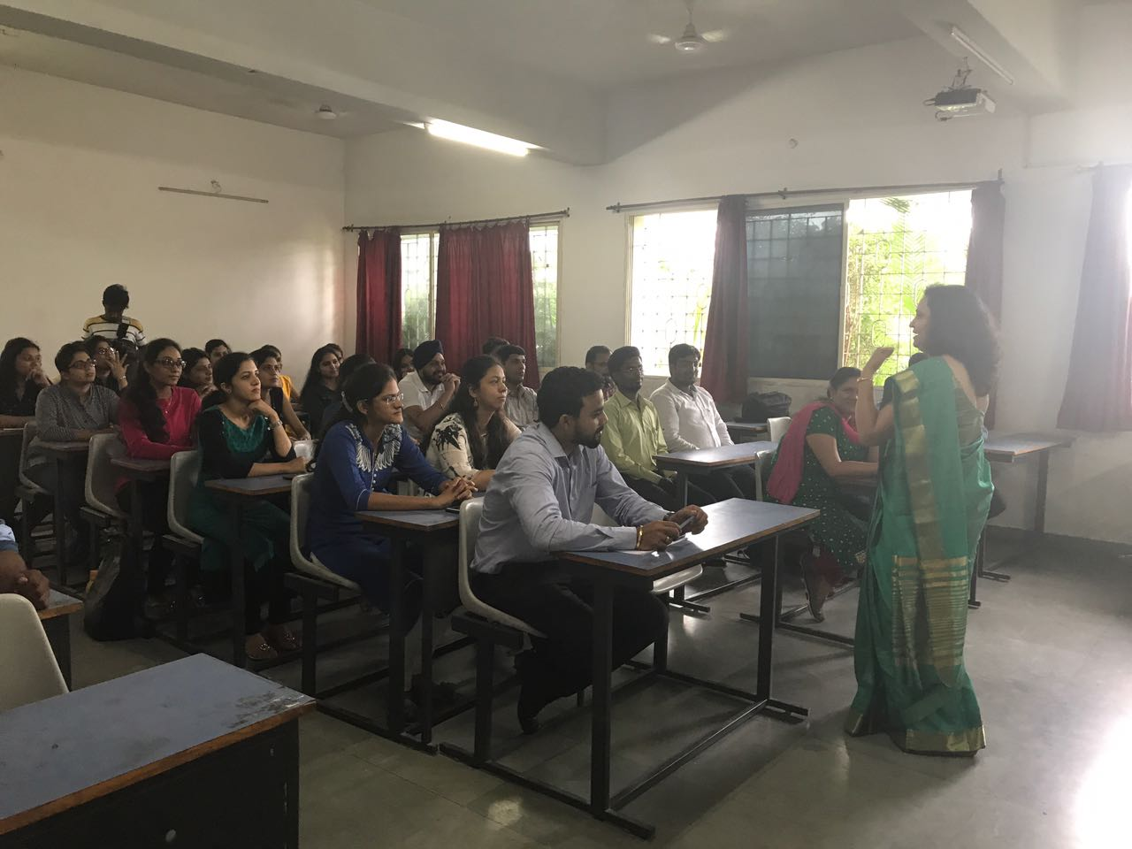
Dr. Varsha Deshpande addressing the alumni.

- INTERCOLLEGIATE TURNCOAT COMPETITION: 12th August, 2017
Every year Alumni of Department of Law, come up with their generous contributions for their alma mater in one or the other form. On 12th August, 2017 the Law Alumni had organized an Intercollegiate Turncoat competition. The topic for the Competition was “Mental Age- The only appropriate determinant to establish guilt of a juvenile in a criminal trial”.
About 15 participants from different Law colleges of the city, such as Maharashtra National Law University, Nagpur, G.H. Raisoni College of Law, Dr. Babasaheb Ambedkar College of Law, Main Branch as well as City Branch had actively participated in the event. A slot of 6 minutes was allotted to each participant, where they had to speak for and against the motion for 3-3 minutes.
The jury team comprised of Adv. Rahul Dhande and Adv. Suyog Deshpande both practicing at Bombay High Court, Nagpur Bench, ably judged the competition. The event was graced by Dr. A.P. Joshi, Vice Principal, Dr. Ambedkar College, Deekshabhoomi, Nagpur, Dr. N.M. Khirale, Head of Department of Law, Dr. H.V. Menon, Dr. Varsha Deshpande, Dr. Sandhya Kalamdhad, Dr. Pratima Lokhande, Prominent Alumni of the Department and other Faculty members.
The event was full of enthusiasm where the participants passionately put their views on the topic. Adv. Rahul Dhande, one of the jury also laid emphasis on the topic and explained the different aspects which needed attention.
1st prize, a cash prize of Rs. 2500/- was won by Ms. Aditi Tripathi, a student from Maharashtra National Law University, Nagpur and 2nd Prize, a cash prize of Rs. 1500/- was bagged by Ms. Prachi Agrawal, Dr. Babasaheb Ambedkar College of Law, Main Branch. The event was conducted by Mrs. Vaishali A. Sukhdeve, Faculty as well as alumnus of the Department of Law.
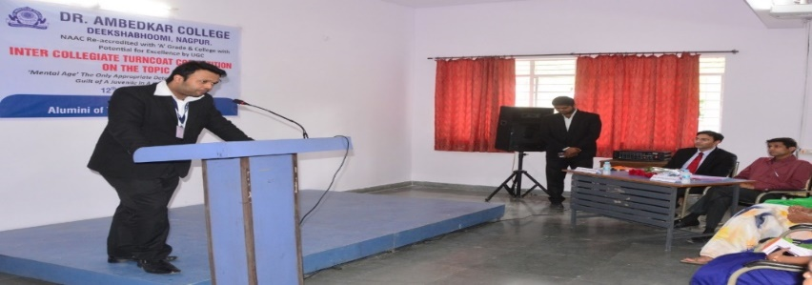
Participant, Amitesh Bhattacharya , along with the jury members.

- ‘CONQUEST EXEMPLAR’ OF THE YEAR
This competition, based on Constitutional Law, is an idea conceived by the teachers of the Department of Law, with a view to instilling an enduring love for Constitutional Law amongst the students and for encouraging them to keep their quest for perpetual learning alive. It is for the very first time that an event like this has been organized in the Department.
This competition will include year long series of different events/ competitions based on Constitutional Law ranging from solving written objective question papers, to writing essays and research papers, making oral presentations, judgment analysis with critical appraisals, group discussions, quiz competitions etc. The evaluation of students will become more and more stringent with every successive round to make the event really competitive for the students. This competition will follow the system of eliminations after the third round and the best amongst them will be pushed to the next rounds. On the basis of their cumulative scores, the best student will be selected who will win the coveted title of "CON-QUEST EXEMPLAR OF THE YEAR 2017" along with a cash prize of ₹ 5001/-
Interested students were first asked to enroll for the competition and the entry was only through enrolment. A total of 44 students enrolled for it. So far two rounds of competition have been held. The first elimination will start after the first three rounds, on the basis of their cumulative score of all the three rounds taken together.
The first round was a written question paper with multiple choice questions. There were 50 questions with 50 minutes given to the students to solve it. This opening round was held on and had the enthusiastic participation of the contestants. The second round was also a written round but this time questions were without any choices, unlike the former multiple choice questions. This paper has 50 questions with 30 minutes allotted to the students for solving it. This was held on 11th August 2017. The third round which is scheduled on 6th Sept will have two parts- the first is a crossword puzzle and the other will have all case law based questions.
There are 3 pilot faculties of this ambitious project: Dr Mrs Varsha Deshpande, Ms. Saylee Surjuse & Mrs. Vaishali Sukhdeve.
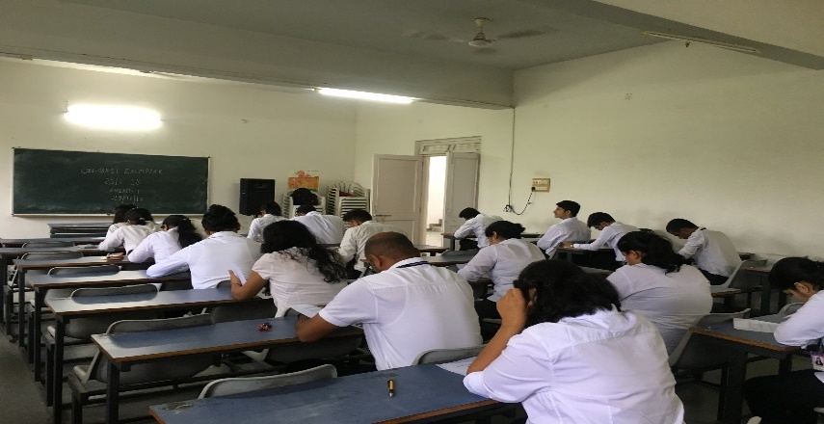
First round of the Conquest Exemplar
4. CERTIFICATE COURSE IN, ‘FORENSIC SCIENCE & CRIMINAL JUSTICE SYSTEM’ : 5th August- 16th August
Department of Law and Department of Biochemistry, of Dr. Ambedkar College, Deeksha Bhoomi, had organised a twelve days Certificate Course in “Forensic Science and Criminal Justice System” from 5th August- 16th August. The course got overwhelming response. The participants who were interested in this course were near about 120. But due to limited number of seats only 76 participants were allowed on first come first serve basis.
The erudite resource persons invited to deliver lectures on different topics for this course included the forensic experts, Professors, Medical practitioners and lawyers. It included the team of 11 resource persons which were Dr. S.L. Deshpande, Dr. Makrand Vyavhare, Dr. Mukherjee, Mrs. Bhoomi Mehere, Dr. Manoj Bhandarkar, Mrs. Hansi Bansal, Dr. Ashish Badiye, Mrs. Neeti Kapoor, Adv. Mahendra Limaye, Prof. Pradeep Hirapure and Adv. Chetan Dhore.
Day 1- 05/08/2016: Inaugural Ceremony
The Certificate Course had been inaugurated on 05th August 2017 at the auspicious hands of Adv. Firdos Mirza, a renowned criminal lawyer practicing in Bombay High court, Nagpur Bench. It commenced by garlanding and lightening the traditional lamp before the portrait of Tathagat Bhagwan Gautam Buddha and Dr. Babasaheb Ambedkar. Dr. N.M. Khirale, Head of the Department of Law, gave a Welcome Speech and welcomed the Guests with a floral bouquet and shared his views on the certificate course.
Adv. Firdos Mirza, in his inaugural speech, emphasized that how Forensic science and Criminal Justice System is complementary to each other. He also questioned that what would happen to the trial, if charge sheet is filed without Forensic Science report. He further emphasized that change in criminal law is required for the better utilization of Forensic Science in criminal investigation.
Dr. Sandhya Kalamdhad, Course Co-ordinator, introduced the whole module of the Course to the participants and focused on the various career options available to the participants as Forensic Scientists and Forensic attorneys. She emphatically pointed out as why scientists and lawyers must come together in partnership to ensure a product that is fit for the criminal justice. The proceedings were conducted by Ms. Janvee Kulkarni, student of the Department of Law and Vote of Thanks was proposed by Ms. Shazia Bari, faculty of the college. Dr. A.P. Joshi, Vice Principal of the college, Dr. N.M. Khirale, Head of the Department of Law, Mrs. B.A.Mehere, Head of the Department of Biochemistry, Dr. Arun Joseph, Registrar, all these were prominently present on the occasion.
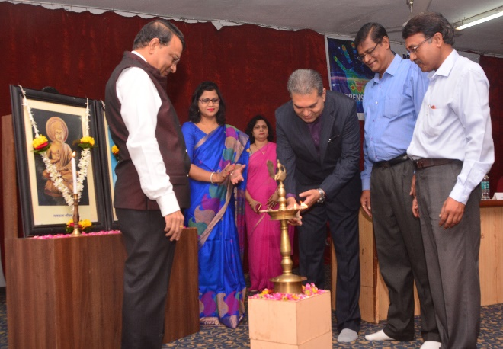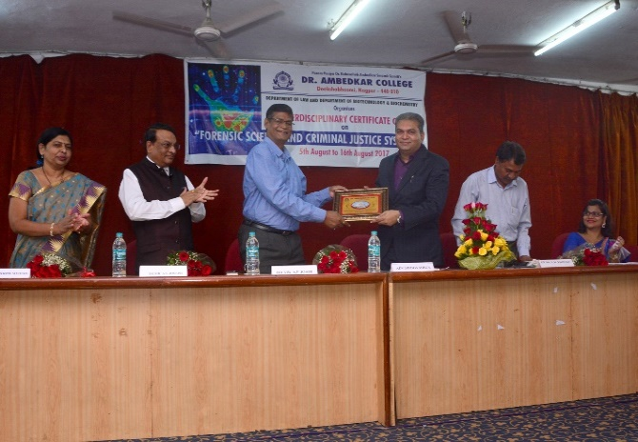
Adv. Firdoz Mirza inaugurating the course along with other dignitaries

Soon after the inaugural ceremony the first session was commenced. The resource person was Mrs. Bhoomi Mehere, Head of the Department of Biochemistry, Dr. Ambedkar College, Deeksha Bhoomi,Nagpur. The topic of her presentation was “Introduction to historical development of Forensic Science”. She laid emphasis on the historical background ranging from the incident of Cong Ci, to Marsh Test. She further described the importance of Ballistics as well.
Day 02- 06/08/17 : The speaker for this session was Dr. Manoj Bhandarkar, Assistant Director, Regional Forensic Science Laboratory, Nagpur. The topic which he covered was “Growth of Forensic Science Laboratories and their utilization in Criminal Justice System in India”. He discussed and laid emphasis on the importance of various departments of Forensics like Forensic Physics Department, Forensic Biology Department, Forensic Chemistry Department and Forensic Ballistics Department. He further elaborated on these different departments are helpful for judiciary in arriving at a proper conclusion.
Day 03- 07/08/17: The resource person who gave her consent for this day’s lecture was Mrs. Hansi Bansal, An Assistant Professor from Department of Forensic Science Institute, Nagpur. The topic which she discussed was “An introduction to examination of questioned documents”.
Day 04- 08/08/17: On this day two sessions were there. First session was taken by Dr. Ashish Badiye, Head of Department, Department of Forensic Science, Institute of Forensic Science, Nagpur. His topic for lecture was “The importance and value of scene of occurrence for administration of Criminal Justice System”.
Second session was presided by our next speaker, Mrs. Neeti Kapoor, Assistant Professor, Department of Forensic Science, Institute of Forensic Science, Nagpur. She delivered a lecture on the topic “Human identification and fingerprint in criminal investigation – A Review”.
Day 05- 09/08/17: Dr. Manoj Bhandarkar, Assistant Director, Regional Forensic Science Laboratory, Nagpur, was again invited to deliver a lecture on the topic “The role and importance of Forensic evidence in criminal trials with special reference to sec. 293 of the Cr.P.C.”
Day 06-10/08/2017: The eminent medical Professional, Dr. Makarand Vyawhare, Head of Department & Professor, Indira Gandhi Medical College, Nagpur was invited to share his experience in the Medical field with the participants. The topic on which he laid emphasis was “Forensic Medicine: An effective tool for proving guilt or innocence”.
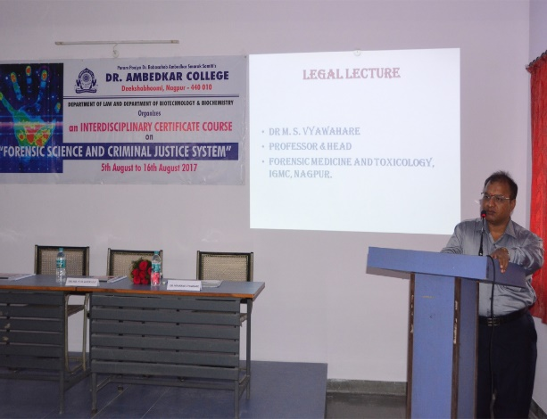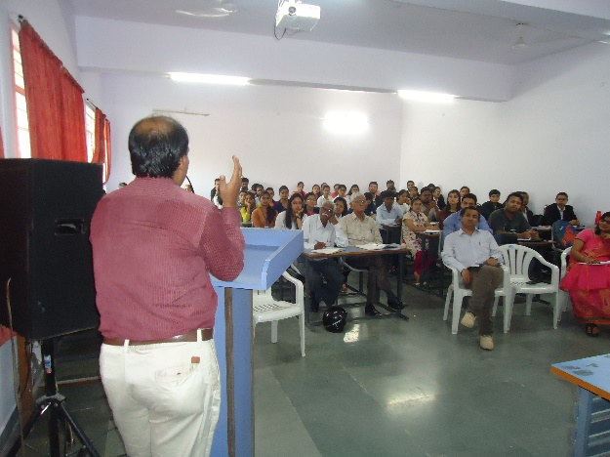
Dr. Makrand Vyawhare & Dr. Mukherjee addressing the participants

- GUEST LECTURE ON GOODS & SERVICES TAX : 29th July 2017
On 29TH July 2017, a guest lecture on Goods And Services Tax was organized for the students of all the groups of LL.M. CBCS pattern of the academic session 2017-18 in the Seminar Room of the Department at 10:00 am by the LLM Faculty, Law Department, Dr. Ambedkar College, Deekshabhoomi, Nagpur. The lecturer was delivered my Mr. Kunal Budhraja, an associate at Budhraja & Company.
The session began at 10:10 AM after seeking the blessings of Lord Gautam Buddha and Dr. Babasaheb Ambedkar. It was followed by the introductory address by the Head of the Department, Dr. N. M. Khirale welcoming the guest. The LL.M. student Ms. Darshana Mohota conducted the session.
Mr. Budhraja through his lecture enlightened the students about the necessity of this new law which replaced the old tax system in India and brought a single taxing regime for the entire country. He also explained the idea of the government for taking this bold step by elucidating the necessity felt by the State to bring this reform in the light of changing economic scene and the government’s promise to reduce tax frauds and curbing the influx of black money within the country. The complexities of the previous tax laws and the simplicity of the new law was also contrasted. The students contributed by asking loads of questions and my getting their doubts solved regarding this newly enacted law and thereby acquiring an insight on the same. The entire Guest Lecture was given with the help of power-point presentation.
The lecture was organized and coordinated by Ms. Aditee A. Godbole, Ms. Sayalee Surjuse and Ms. Shazia Bari under the guidance & supervision of the Dr. N. M. Khirale, HOD. Vote of thanks was proposed by Ms. Kalyani Buche.
- GUEST LECTURE ON RERA: 12th August 2017
On 12th August 2017, a Guest Lecture on Real Estate (Regulation & Development) Act, 2016 was organised for the students of all the groups of LL.M. in the Seminar Room of the Department at 10:00 am by the LLM Faculty, Law Department, Dr. Ambedkar College, Deekshabhoomi, Nagpur.
The session began at 10.15 am after seeking the blessings of Lord Gautam Buddha and Dr. Babasaheb Ambedkar. Mr. Parikshit Loya, an Assosiate of the renowned Loya & Bagri firm of Nagpur was invited as the Guest Speaker. The program was compared by Ms. Darshana Mohota, LL.M. 3rd semester student while Ms. Subodhini Zanke, a student of 3rd semester welcomed the guest with a floral bouquet. It was followed by the introductory address by the Head of the Department, Dr. N. M. Khirale.
The guest speaker threw light on the importance of the legislation which happens to be the only law on the till now un-organised sector of real estate. Mr. Loya explained the students about the scheme of the Act in detail. He talked about the modes of registration with the RERA authorities of the upcoming and the on-going projects. He also explained the penalty feature incorporated in the legislation along with the authorities in the RERA Act which looks after the implementation of the provisions of the legislation. He delivered the guest lecture with the help of power-point presentation.
Vote of thanks was proposed by Ms. Kalyani Buche, a LL.M. 1st semester student. The lecture was organized and coordinated by Ms. Aditee A. Godbole, Ms. Sayalee Surjuse and Ms. Shazia Bari under the guidance & supervision of the Dr. N. M. Khirale, HOD.
7. GROUP DISCUSSION ON, “TRIPLE TALAQ IN THE LIGHT OF SHAYARA BANO VS. UNION OF INDIA”: 9th Sep. 2017
The Law Department (LL.M.), Dr. Ambedkar College, Deekshabhoomi, Nagpur had taken an initiative to organize a group discussion on the topic “Triple Talaq In the Light of Shayara Bano Vs. Union of India of on 9th September, 2017 at 9:00 am in the Department. India is a home to world’s third largest Muslim population. However, the pathetic plight of a Muslim woman can be witnessed from the fact that she has to face a constant threat of sudden, oral and out of Court divorce. This prompted the organizers to choose “TRIPLE TALAQ” as a topic for the group discussion.
The panel for discussion consisted of 8 students from LL.M 1st and 3rd semester. The participants tried to critically analyze the judgment given by the Hon’ble Supreme Court in Shayara Bano Vs. Union Of India. During the discussion, various aspects of triple talaq were discussed by the participants including the place of nefarious custom like triple talaq in a democratic State like India where gender equality is given utmost recognition even in the Constitution of India. The participants also gave insight into the legal intricacies involved in the said decision that whether triple talaq is a part of essential practice of Islam religion and the propriety of the judiciary interfering into religious matter of Muslim community despite the fact that India is a secular Country where freedom of religion is guaranteed by way of a fundamental right. The group discussion was concluded with a concern towards the enactment of Uniform Civil Code without undermining the secular ethos of our Country.
All the participants were assertive and put forth their thought provoking views on the aforementioned topic. The group discussion was conducted by one of the LL.M. faculty members Ms. Shazia Bari. Other faculty members Ms. Sayalee Surjuse and Ms. Aditee Godbole took conscientious efforts in organizing the group discussion.
- TEACHERS DAY CELEBRATION : 5th September 2017
Students of Ll.B. 5yc & 3 Yc. Celebrated Teachers day and really made this day memorable for all teachers. Different kind of games and cultural programme was organised for the teachers of the department. All teachers and non-teaching staff was warmly welcomed and felicitated by the students.
- GUEST LECTURE ON FOREIGN EDUCATION : 7th Feb. 2018
The Law Department of Dr. Ambedkar College, Deekshabhoomi, Nagpur organised a Guest Lecture on 7th February 2018 at 12:15 pm on the Topic –‘Foreign Education in Law’ in the seminar room of the Department. Mr. Arpit Ajmera, Branch Manager, IDP Education, India Pvt. Ltd. was the guest speaker for the day. The guest speaker was welcomed with a floral bouquet by a student of the LL.B. final semester.
Mr. Arpit Ajmera started with pointing out the importance of post graduation in the field of Law. He informed the students about the different avenues available to them in various countries. He provided a good insight on the unconventional courses offered by the various Foreign Universities to Law Graduates which could provide good future employment prospects. He demonstrated with the help of power point presentation as to how the complete process from selection of the Course to selection of University to the completion of VISA process is taken care of by IDP Education India Pvt. Ltd. After the completion of his lecture, Sir dealt with the questions from the audience with great zeal and enthusiasm and answered them to their satisfaction. The guest lecture was coordinated by Dr. Mrs. Hema Menon and Ms. Sayalee Surjuse.
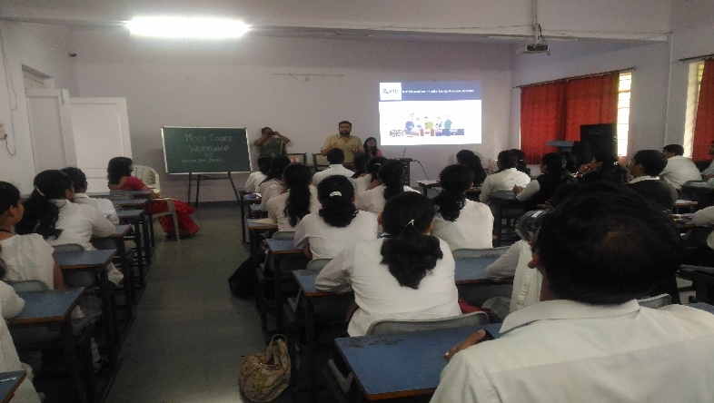
Mr. Arpit Ajmera addressing the students.

- DEBATE COMPETION : 12th Feb. 2018
Debate competition was organised on a very contemprory topic, “One man, One Woman or More”, for the students of Ll.B. 2nd & 4th Sem. Of 5yc and 3 yc. 10 teams participated in the competition. Adv. Vivek Awchat and Adv. Rekha Barhate ably judged the competition. Ms. Kajal Gupta won the first prize and runner up was Mast. Pushkar Deshpande, both students of 4th Sem. 5yc. Dr. Sandhya Kalamdhad organized the competition.
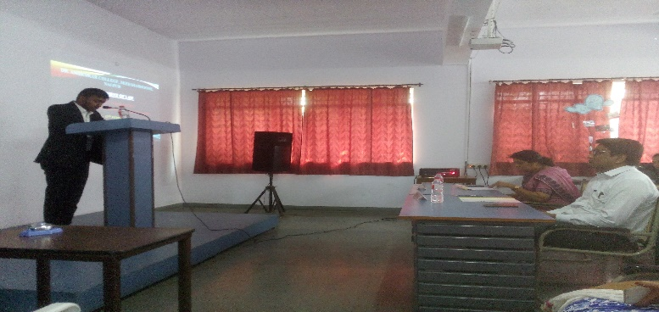
Hon’ble Judges, judging the competition.

- GUEST LECTURE BY ADV. RAJESH THOMAS : 13th Jan. 2018
Adv. Rajesh Thomas, Barrister & Solicitor, Newzeland Law Society, NEWZELAND, delivered a lecture on the topic, “International Law and Immigration”, organised by department of law, Dr. Ambedkar College, Deeksha Bhoomi, Nagpur for the UG & PG students of Law. He compared the legal system of two countries and elucidated the subject and answered the questions by students. Enthusiastically students interacted with the speaker. Programme was conducted by Mrs. Vaishali Sukhdeve and co-ordinated by Dr. Mrs. Sandhya Kalamdhad.
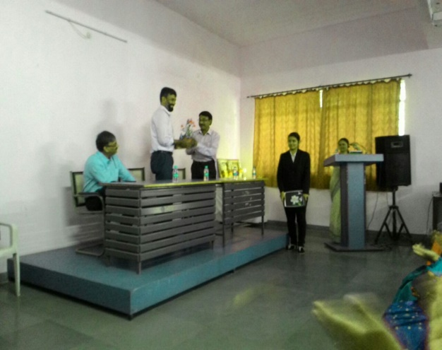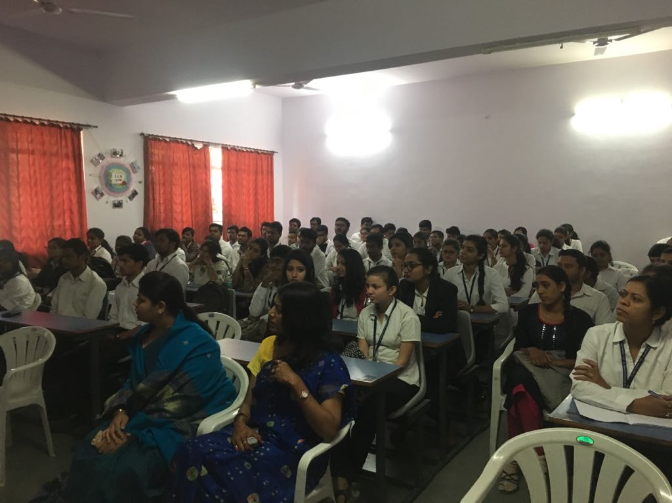
HOD welcoming the Guest speaker and audience.

12. WORKSHOP ON MOOT COURT SKILLS : 6th Feb. 2018
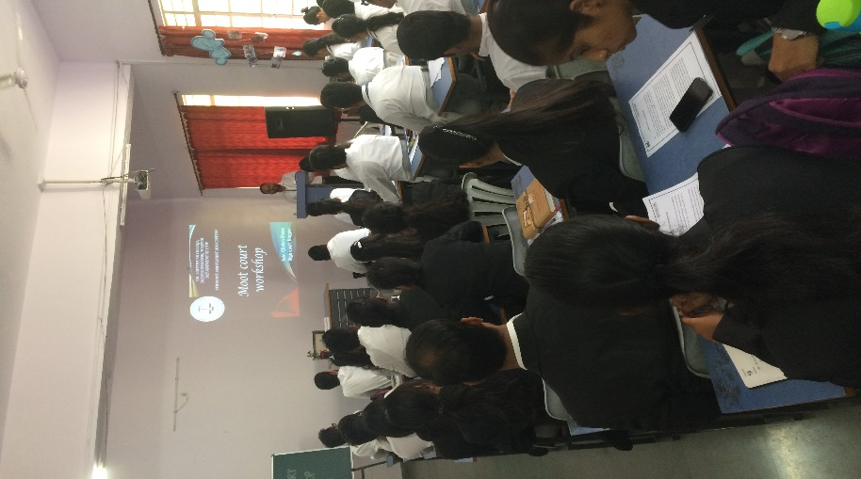
The workshop was held on 6th Feb, 2018 at 2pm for the students of law to introduce them with the mooting skills so that they can participate in different moot competition at across the nation. Adv. Chetan Dhore ably guided the students on Court ethics, how to conduct research, how to cite cases, ratio decedendi, case study etc. he also informed the students about prestigious moots conducted at various levels. Programme was conducted under the banner of SMCA and co-ordinated by Dr. Varsha Deshpande and Dr. Sandhya Kalamdhad.

Adv. Chetan Dhore addressing the students.

13. CONQUEST EXEMPLAR 2017-2018
- The Event I was held on 29th July 2017 which was a Multi choice Question paper of 100 marks without negative marking. Total 44 participants participated from different classes.
- The Event II was held on 11th August 2017 which was a Multi choice Question paper of 100 marks with negative marking. Total 44 participants participated from different classes.
- The Event III was held on 7th September 2017 which was a Crossword round of 100 marks with negative marking. Total 44 participants participated from different classes.
After three events elimination started. On the basis of cumulative scores of three events Top 20 participants were pushed ahead in next round.
- The Event IV was submission of research paper on the topic of Right to Privacy and its various sub themes. The last date for paper submission was 11th December.
- The Event V was held on 13th January 2018 which was a Research paper presentation round, in which total 13 students presented their paper. The topic was Right to Privacy and its various sub themes The examiners to judge this event were Adv. Renuka Sirpurkar and Adv. Shradhanand Bhutada.
- The Event VI was held on 10th February 2018 which was a Judgement analysis round, in which total 09 students participated which were shortlisted on the basis of their previous rounds cumulative scores. The examiners to judge this event were Adv. Priti Rane and Adv. Ritesh Tahaliyani. The case given for analysis was ABC vs. State 2015 SCC 609.
- The Final round of the event was a Constitutional quiz which was held on 20th February 2018 in the College auditorium. The top 4 finalist were selected on the basis of cumulative scores of all events. The quiz was conducted by Dr. Varsha Deshpande. The Conquest Exemplar 2017-2018 was won by Ms. Priyanka Bodhankar, a cash prize of Rs. 5000/- which was sponsored by Dr. Varsha Deshpande. The prize were given at the valedictory function of law-Vision 2018 at the hands of J. Mrs. Naik, High Court, Nagpur.
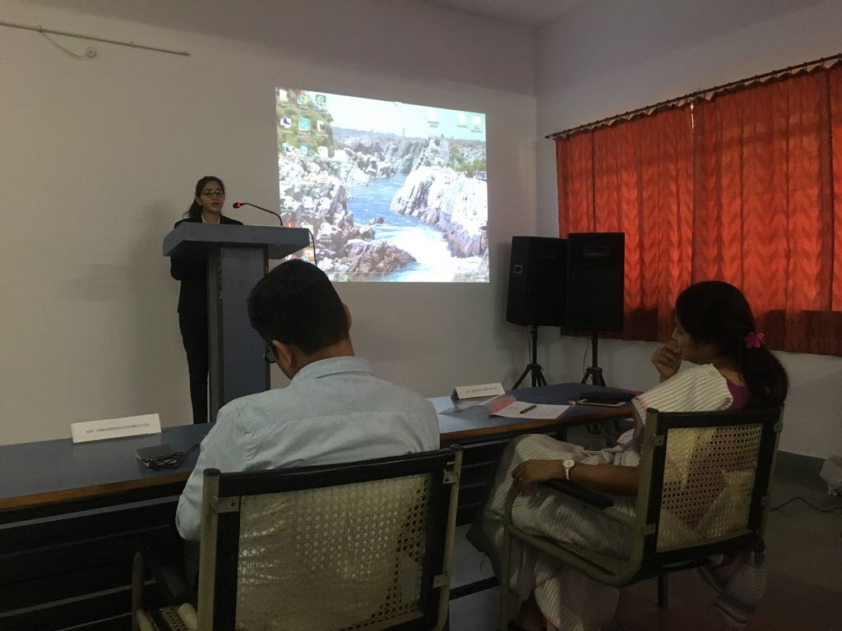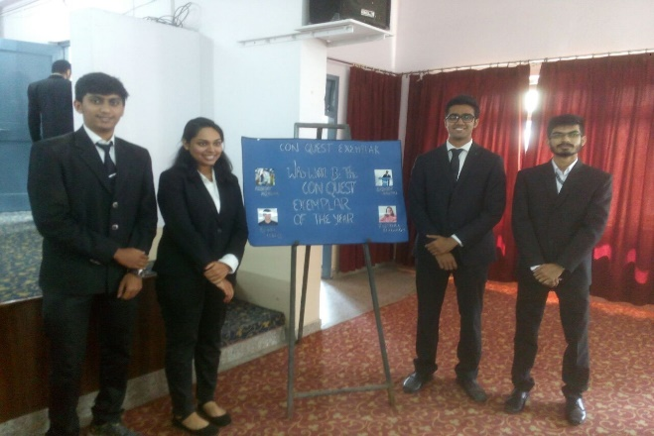
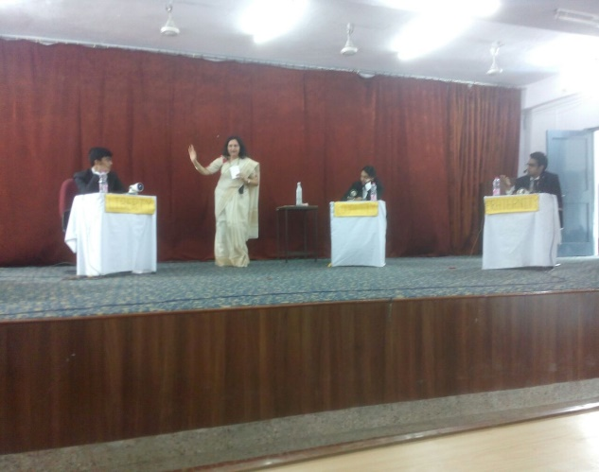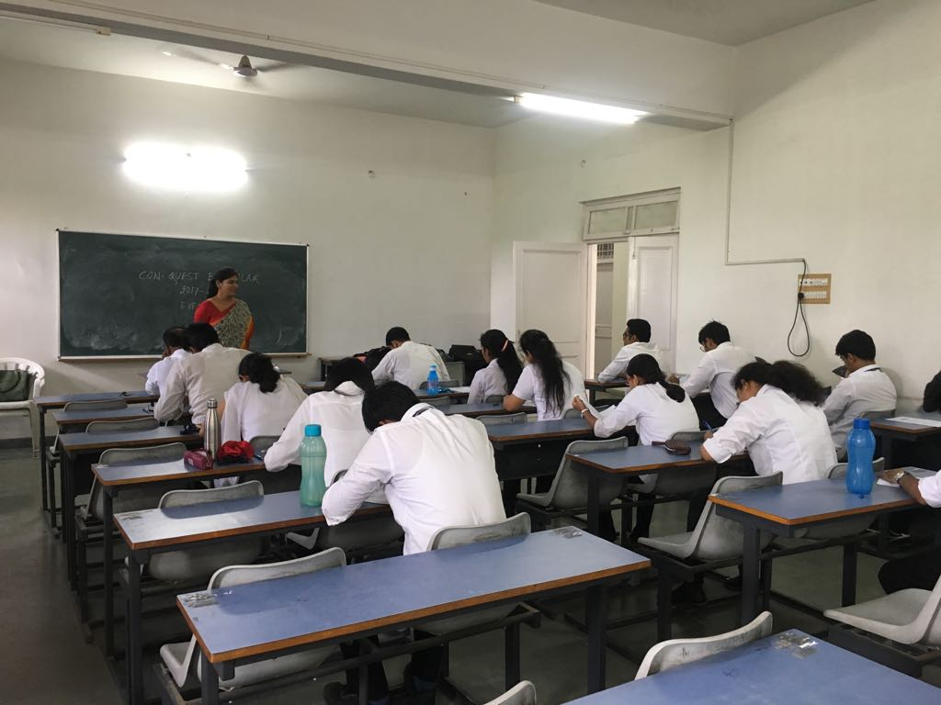
Students participation in different competitions during conquest Exemplar

- FREE LEGAL AID AND LITERACY PROGRAMM
Free Legal Aid camp and Literacy programme was organized by Legal Aid cell of Department of Law on the occasion of Dhammachakra Pravartan to provide free legal aid to thousands of people who come to Deekhabhoomi on Dusshera on 29th, 30th September and 1st October 2017. The programme was inaugurated by Hon’ble Shri Justice Rohit Deo who was the chief guest at the event. The other dignitaries on the dais were Shri. N. R. Sute, member of ParamPoojya Dr. Babasaheb Ambedkar Smarak Samiti , Principal Dr. P. C. Pawar and Dr. N.M. Khirale , H.O.D. of Law. In his address Hon’ble Shri. Justice Rohit Deo highlighted the importance of legal aid and motivated the students to take part in social causes.
During the camp under the supervision of faculty members Mr. Rahul Dhoble, Mrs. Vaishali Sukhdeve, and Mrs. Shilpa Rathod and Miss Shazia Bari, students of Department of law explained the charts displaying various legal rights to the people and also distributed the booklet containing information about different Government Schemes. The programme was conducted by Mr. Sachin Tripathi .Vote of thanks was given by Dr. Pratima Lokhande.
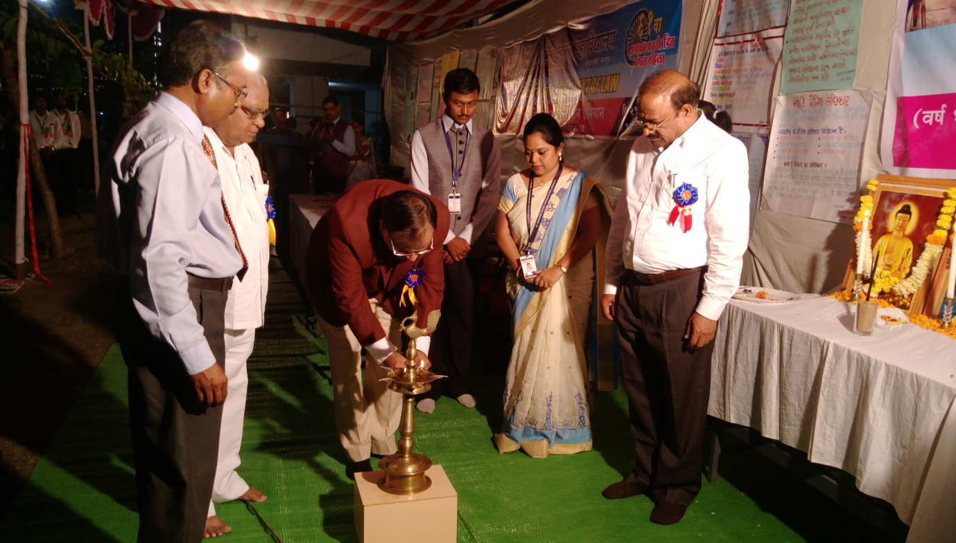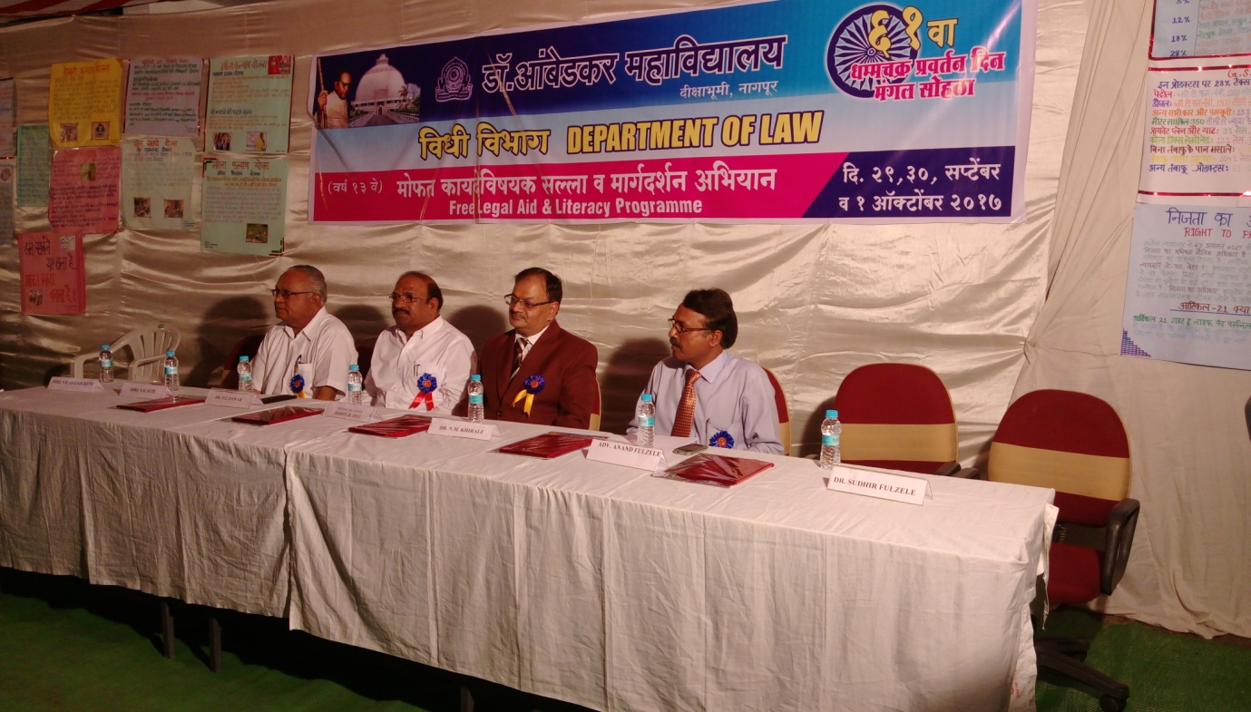
Shree J. Rohit Deo inaugurating the Camp & Dignitaries present on the dias.

15. Law Vision - 2018
Law Vision is a highly sought after premiere law festival that is organized by the Department of Law every year. The Department has been hosting this event for the last 11 years and this was the twelfth consecutive year of this mega law festival. Law Vision 2018 was hosted by the Department from 22nd Feb to 25th February this year and it received an overwhelming response. In all 14 teams from all across the country, including from far-flung places like Andaman participated in this academic extravaganza and all the teams gave a tough fight at various challenging competitions at Law Vision. This year events like Moot Court competition, Client Counselling competition, Case-Study, Legal Drafting, Essay Competition and Personality Contest were a part of Law Vision – each one testing the requisite skills necessary for emerging as successful professionals. The corridors of the Law Department were all set to host this grand event, decorated as they were with beautiful rangolis and several charts and other displays made by our own talented students.
This year, Law Vision was inaugurated in a glittering Inaugural ceremony on Thursday, the 22nd of February at 6 pm in the College Hall. The Inauguration ceremony got under-way in the presence of towering legal personalities. Justice B P Dharmadhikari, the Senior Administrative Judge of the Nagpur Bench of the Bombay High Court was the Chief Guest of the Ceremony and the Hon’ble Vice Chancellor of the Maharashtra National Law University was the Guest of Honour. Also Hon’ble Mr Mohan Pieres, the Former Chief Justice of Srilanka graced the occasion as a Special Guest. The motivational speeches of all these legal luminaries set the tone and marked a wonderful beginning of this Law festival!
The second day of the event i.e. 23rd of February began with the Client Counselling competition for all the participating teams. This Competition is organized with a view to train the future lawyers in the art of receiving instructions from the client and the kind of interaction that a lawyer must have with the client in order to muster his confidence. It also seeks to test the professional ethics of these would-be lawyers and their understanding about the duty that lawyers owe to their clients and to the court. This competition was ably judged by Adv Suyog Deshpande and Adv Ashwini Shukul. The event was co-ordinated by Ms Sayalee Surjuse, Ms Aditee Godbole and Ms Shazia Bari.
Soon after this, a Legal Drafting competition was also organized for the teams, wherein, the teams were asked to draft some important legal documents like Notice, Plaint, Affidavit, Sale-Deed etc. The teams were adjudged on the basis of their compliance to formal rules of drafting as well as the content and comprehensiveness of the draft. Drafting skills are at the very heart of the lawyers profession and hence this competition was organized with a view to hone their drafting skills. The event was co-ordinated by Dr Pratima Lokhande and Ms. Shilpa Rathod and judged by Adv Chetan Dhore from the High Court.
After this, the second half of the day was marked by the conduct of the Preliminary Rounds of the Moot Court competition. The students were required to prepare the given case, draft memorials and argue the matter like it is done in the Court of Law. The Moot Court event requires a student to master all skills of a lawyer like studying and appreciating the case, framing of issues, researching the case law, drafting the memorials and actually arguing the matter. This was a tough competition indeed and in the Preliminary round, the teams were required to argue from both sides. There were 7 court rooms created for this event and the following lawyers from the Nagpur High Court did a fine job of grilling the teams on different issues relating to the case. The able judges were: Adv Akshay Naik, Adv Saurabh Chaudhary, Adv Tajwar Khan, Adv Deoul Pathak, Adv Trupti Udeshi, Adv Akshay Sudame, Adv Richa Tiwari, Adv Prasad Abhyankar, Adv Ritesh Tahaliyani, Adv Rohan Joshi, Adv Preeti Rane, Adv Ritesh Badhe, Adv Rahul Dhande and Adv Ranjit Bhuibhar. The second day of Law Vision ended with testing and grilling rounds of the Preliminary rounds of the Moot Court competition. All rounds of the Moot Court Competition were co-ordinated by Dr Varsha Deshpande, Ms Aditee Godbole and Mr Sachin Tripathi.
The third day of Law Vision i.e. 24th February, Saturday, began with an eloquent lecture by one of the finest legal brains in the country, Adv Prashant Bhushan , who was invited from the Supreme Court of India. This Guest Lecture became the headline of this Law festival and drew a huge crowd of listeners from the entire legal fraternity in Nagpur and also others unconnected with the profession. He delivered an erudite address on a topic of contemporary significance, namely, “Judicial Accountability and Judicial Reforms”. In a jam-packed auditorium, this guest lecture sought to bring some fresh thinking on the young minds about the urgent need for making the judiciary accountable. The lecture was followed by an open – house session in which the students and participants got an opportunity to interact with the guest speaker and ask him certain questions. The Guest lecture was given a wide and extensive coverage by the media.
This day, that began on such a wonderful note, kept that spirit going through the Case-Study competition in which the teams were given one case, namely Shreya Singal vs Union of India and the students were expected to critically appraise the judgment. This competition enhances their insight and ability to appreciate the law. This competition was ably judged by Adv Nahush Khubalkar, Adv Vivek Awachat and Adv Mahendra Limaye. The Case- Study competition was co-ordinated by Dr Sandhya Kalamdhad, Ms Vaishali Sukhdeve and Ms Shilpa Rathod. This was followed by a Semi-final round of the Moot Court competition. 4 teams from the Preliminary Rounds, on a two-win basis were pushed into the Semi-final round. The level of this evaluation at this round was tougher still and the teams were judged by Adv Uday Dastane and Adv Shreerang Bhandarkar – both very senior Lawyers practicing in the Nagpur High Court. With such tough and testing competitions, ended the third day of Law Vision.
The final day of this law fest began in the morning with the Final round of the Moot court competition. 2 teams from the Semi-final round were pushed into the final round. This final round of the Moot Court competition was indeed a very prestigious one. It was judged by two esteemed judges of the Nagpur Bench of the Bombay High Court Hon’ble Mr Justice V M Deshpande and Hon’ble Mr Justice Rohit B Deo. The auditorium was jam packed with students who had keenly come to see this final round. The end of this Final round of the Moot Court event navigated us to the Personality Contest which was yet another much enjoyed event at Law Vision. The students were subjected to different rounds and eliminations were done in each round. But all the rounds were carefully crafted so as not to lose our essential legal touch. Out of a total of 15 students, Mr Personality and Ms Personality were declared. This competition was also enjoyed by the audience present in large numbers and was judged by Adv Wilson Mathew and Ms Ketki Kane Salankar, who also happens to be the alumnus of our Department. The Personality Contest was co-ordinated by Dr Mrs Hema Menon and Ms Saylee Surjuse.
The essay competition at Law Vision 2018 required an online submission of the essays on the topic “New Horizons of the Concept of Human Dignity”. All Essays were subjected to an anti-plagiarism check. They were evaluated by Prof Dr Shirish Deshpande, Former Head of PGTD Law, RTM Nagpur University. This competition was co-ordinated by Ms Shazia Bari, Mr Rahul Dhoble and Mr Sachin Tripathi
After the Personality Contest, it was time to conclude this fun-and-learning packed Law festival. Hon’ble Smt Justice Vasanti Naik from the Nagpur Bench of the Bombay High Court was the Chief Guest at the Valedictory Session of Law Vision 2018. Her motivational speech to the students was widely appreciated. The prizes of all the events were distributed in the Awards ceremony at the Valedictory session. Attractive cash prizes were given away for all the winners and runner-up at all events.
With this wonderful valedictory session, were drawn the curtains on this academic extravaganza of the Department of Law - “Law Vision 2018”!
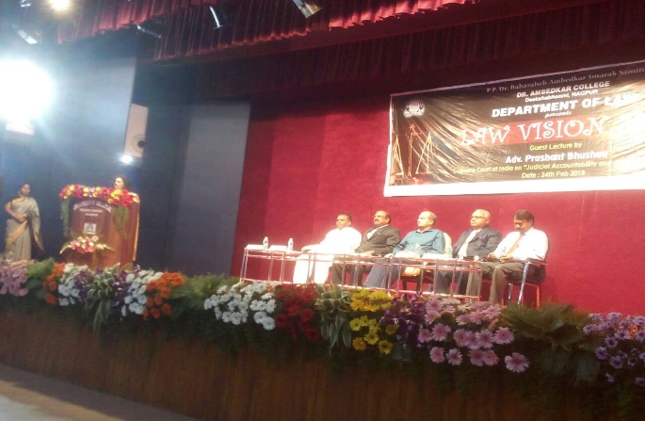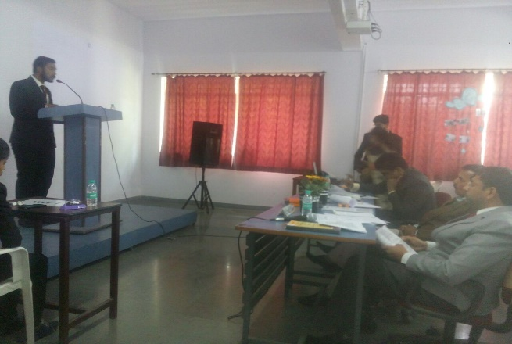
Adv. Prashant Bhushan alongwith other dignitaries & three judges judging case study competition

16. SONEGAON POLICE STATION VISIT
A visit to Sonegaon Police Station was arranged by Legal aid cell of Department of law, Dr.
Ambedkar College, Deekshabhoomi Nagpur for the students of Final Year LLB X Sem 5 YC and VI sem 3 YC on 19th March, 2018. The objective of this visit is to make students aware about the functioning of Police Station and the role of police in the society. A.P. Taksande, P.I of Sonegaon Police station made the students understand the procedural aspects in much practical way. The discussion with Police Inspector and other officials help the students understand all the procedural aspects related to Police station. This visit was organized by Coordinator of Legal Aid cell, Dr. Pratima Lokhande and Mrs. Shilpa Rathod.
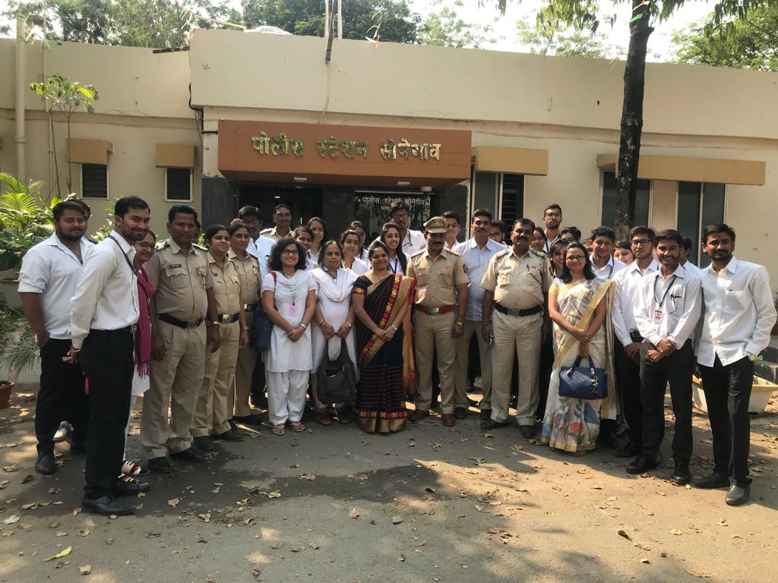
Students along with teachers at Police Station.

17.VISIT TO MEDIATION CLINIC OF DISTRICT LEGAL SERVICES AUTHORTY, DISTRICT COURT, NAGPUR
Legal Aid Cell of Department of Law, of Dr. Ambedkar College, Deekshabhoomi, Nagpur, organized one day visit for final year students of LLB X Sem 5Y.C. and LLB VI sem 3 Y.C. to Mediation Clinic of District Legal Services Authority, District Court, Nagpur on 20th March 2018. At the Mediation clinic student were addressed by Mr. Chandan Jadhav. He explained the students about the Mediation Clinic Scheme. He had also given the detailed information about the procedure of appointment of mediators and filing of application in the matters of family disputes, domestic violence, bailable and compoundable offences. This visit aimed at bringing social sensitivity among the budding lawyers who will have an important role to play in the amicable settlement of the disputes. This initiative was supervised by Dr. Pratima Lokhande, Co-ordinator of Legal Aid cell and Mrs. Shilpa Rathod, Assistant Professor.
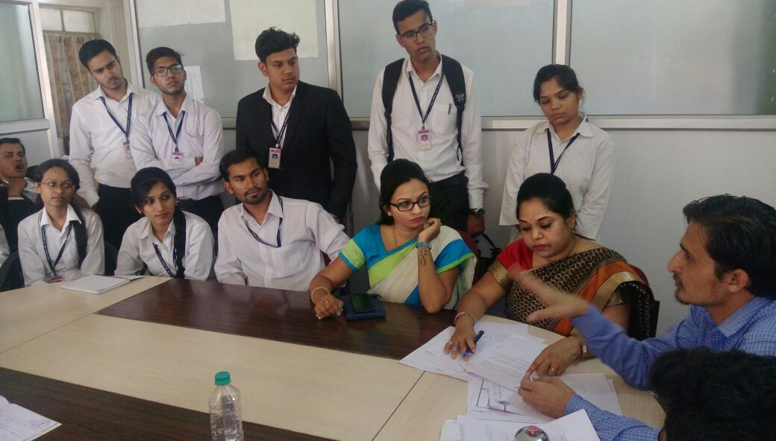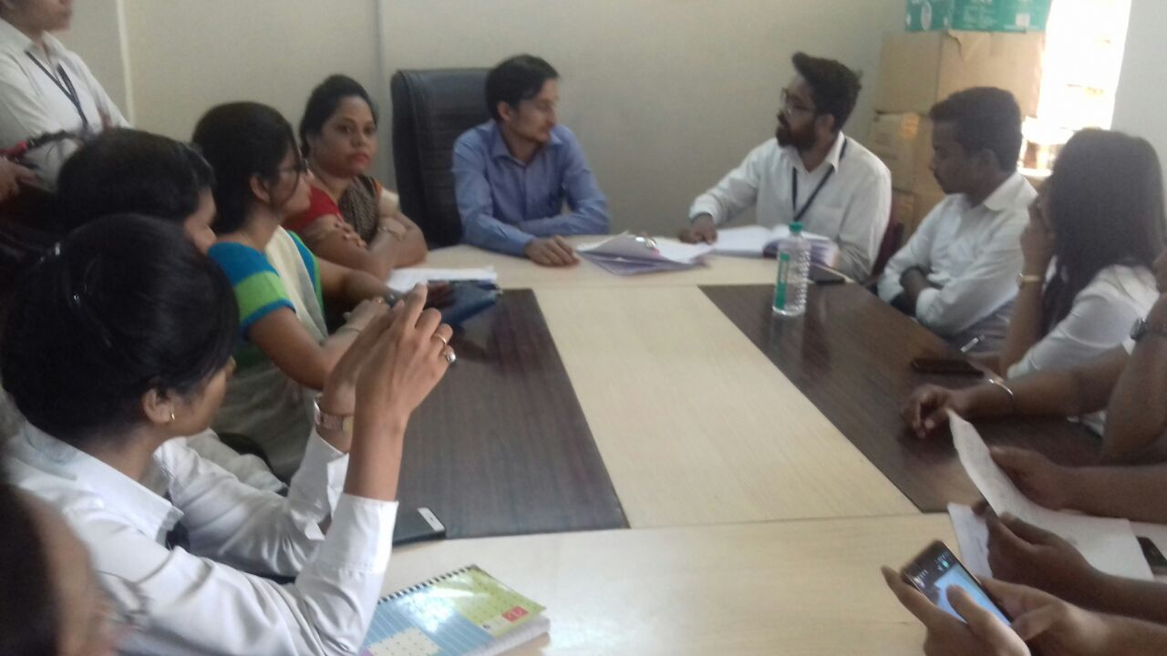
Shree Chandan Jadhao explaining their working pattern to the students
18.VISIT TO LEGAL AID CELL OF DISTRICT LEGAL SERVICES AUTHORTY, DISTRICT COURT, NAGPUR
Legal Aid Cell of Department of Law, of Dr. Ambedkar College, Deekshabhoomi, Nagpur, organized one day visit for final year students of LLB X Sem 5Y.C. and LLB VI sem 3 Y.C. to Legal Aid Cell of District Legal Services Authority, District Court, Nagpur on 20th March 2018. This visit was organized to make students aware about the working of Legal Aid Cell and the concept of Free Legal Aid. The students were addressed by Mr. Selwatkar and Mr. Chandan Jadhav. The students were also informed about the Legal Services Authorities Act, 1987 and various other procedural, legal and social aspects. This visit was organized under the supervision of Dr. Pratima Lokhande, Coordinator of Legal Aid cell and Mrs. Shilpa Rathod, Assistant Professor. Advocate Gajanan Agrwal was also present during the visit.
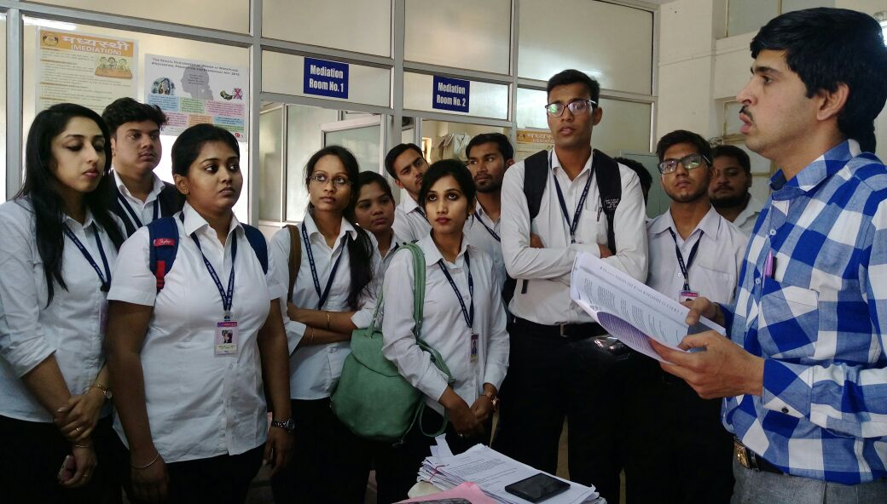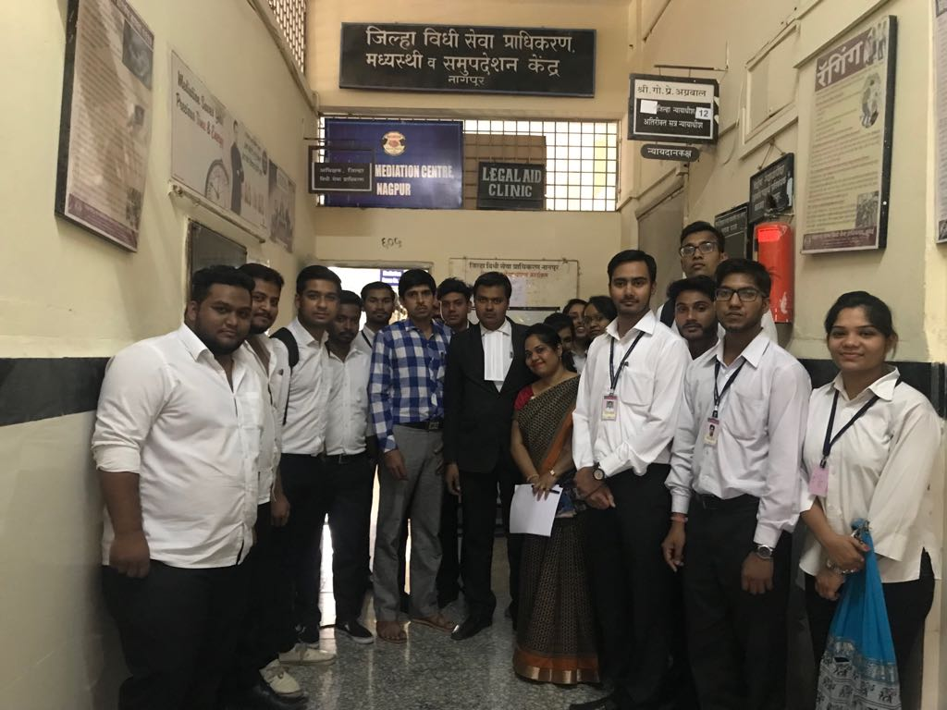
Students with authorities during their visit to Legal Services Authorities
19. CULTURAL PROGRAMME
Cultural programme was organized by Department of Law of Dr. Ambedkar College, Deekshabhoomi Nagpur at College auditorium on 28th February 2018. The events of day long programme included dance, skit, instrumental music and singing. It was an event where law students portrayed their talent. Final year students of Law department took the initiative and organized this cultural event with great enthusiasm. The faculty and students of Department of Law attended the cultural programme. It was filled with full of fun and fancy and was enjoyed by all. Assistant professor, Dr. Pratima Lokhande along with Mrs. Shilpa Rathod supervised the cultural programme.

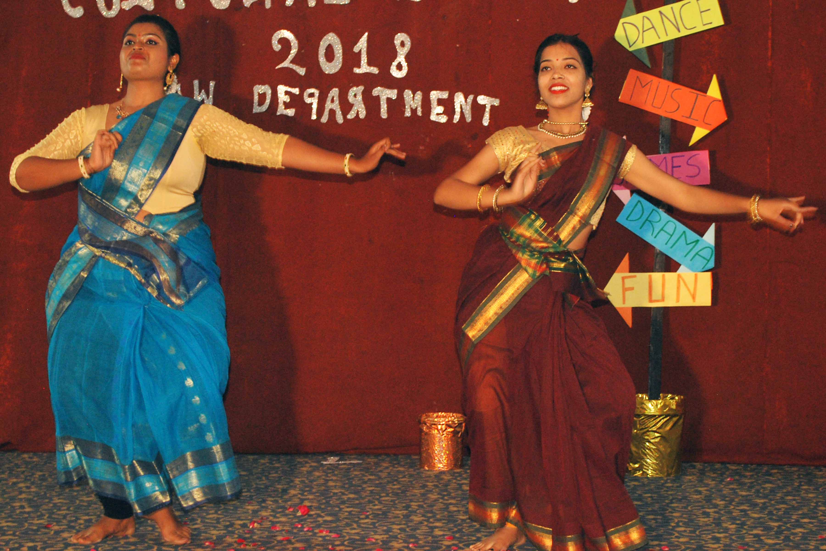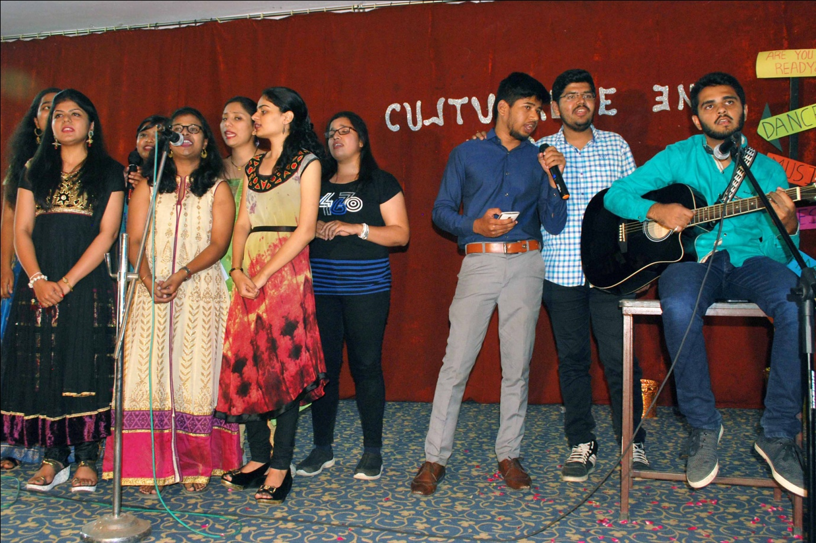
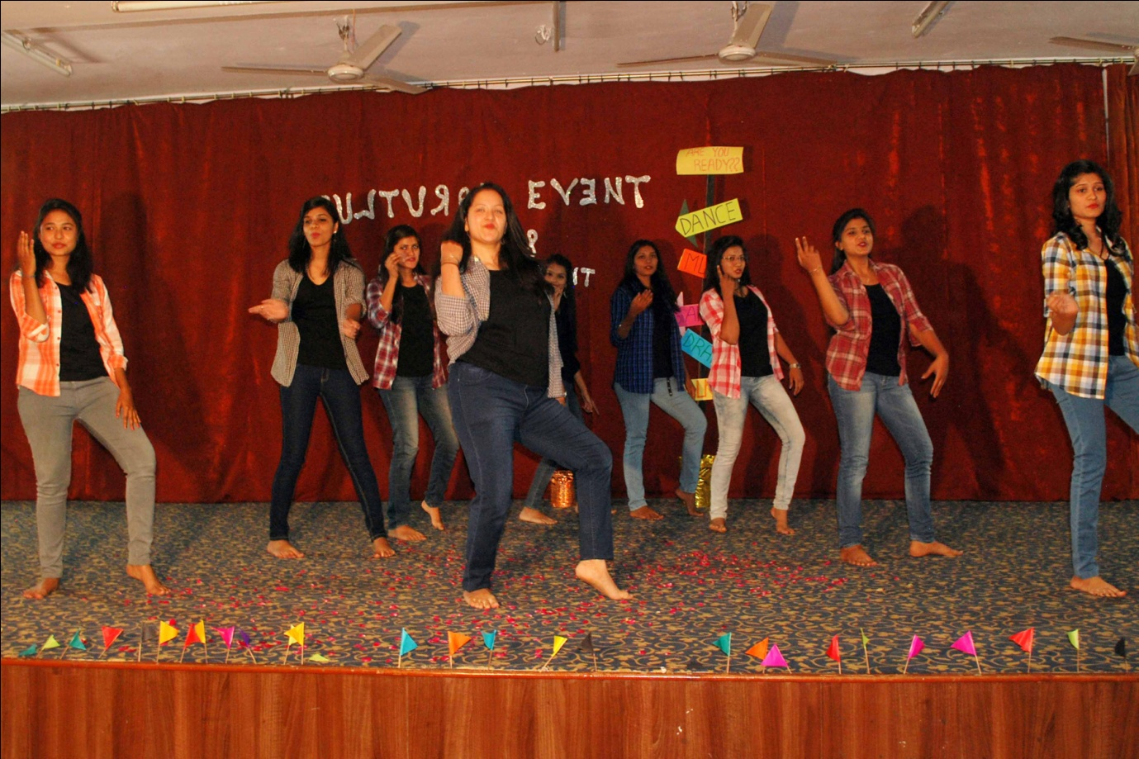
Students of dept. Performing different cultural events.
20. CENRAL JAIL VISIT
Legal Aid Cell of Department of Law, of Dr. Ambedkar College, Deekshabhoomi, Nagpur, organized Central Jail, Nagpur visit for the final year students of LLB X Sem 5Y.C. and LLB VI sem 3 Y.C. on 22nd March, 2018. Dr. Pratima Lokhande, Coordinator of Legal Aid Cell organized the said visit and about 80 students were taken for the central jail visit. The purpose of the Central jail visit was to make them aware about the working and the management of the prison system. The superintendent police officer briefed the students about the daily activities of inmates. All female students were taken to the women prison and all the male students were taken to the male prison. Thereafter superintendent police officer cleared the queries and doubts raised by the students in the question answer session. This visit changed the perspective of the students about the jail and information given by the police officer helped the students in understanding the jail organization and it functioning.
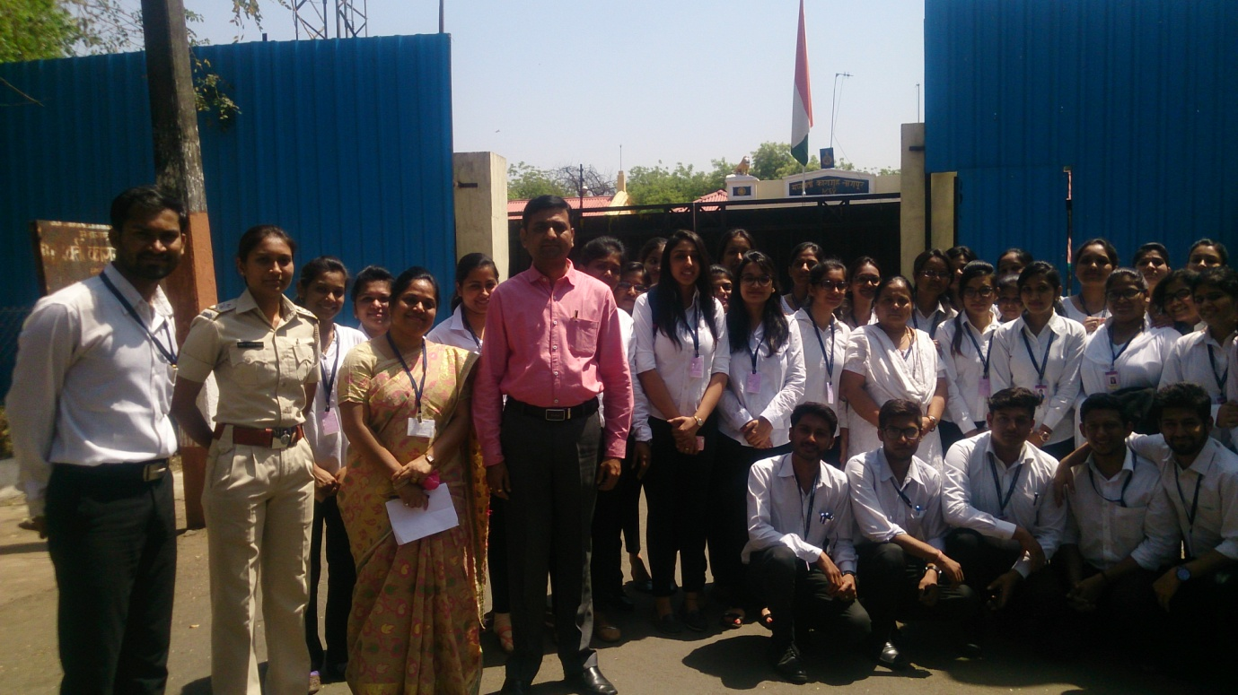
Students along with authorities at the entrance of Central Jail, Nagpur.

21. CELEBRATION OF RUPUBLIC DAY
The 69th Republic day of India was celebrated with great patriotic fervor at Dr. Ambedkar College, Deekshabhoomi, Nagpur on 26th January 2018. The ceremony started with the unfurling of the National flag. This was accompanied by the rendition of National anthem. The Students of Department of Law sang the patriotic song which aroused the feeling of brotherhood amongst all.
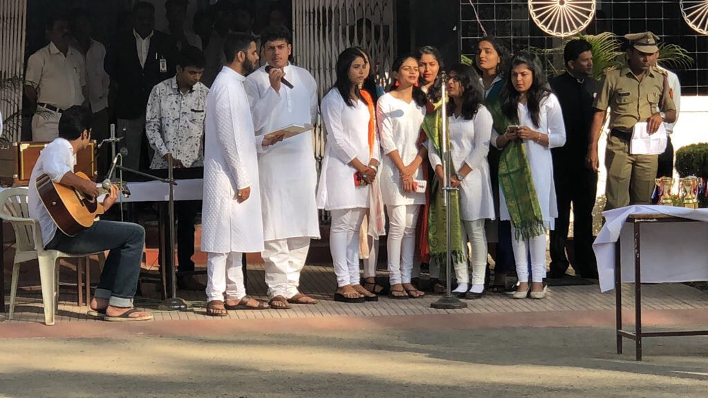
The heartfelt rendition of patriotic song by the students of dept. of law.

22. AWRENESS PROGRAMME ON, “HUMAN TRAFFICKING AND COMMERCIAL SEXUAL EXPLOITATION SCHEME, 2015”
District Legal services Authority (DLSA) conducted awareness programme on “Human Trafficking and Commercial Sexual Exploitation Scheme, 2015”, on 23rd March 2018 at Judges Auditorium 8th floor , District court Nagpur. About 20 member students of Legal Aid Cell of Department of Law along with Dr. Pratima Lokhande attended the awareness programme. The primary objective of the programme was to spread awareness about the scheme. This programme started with the introductory speech given by Mr. A.K. Sharma, Secretary of D.L.S.A. He explained the primary objective of the scheme. Hon’ble Principal Judge Shri. Dongre explained, “The Manodhairya Yojana (Scheme)”. He emphasized that it provides immediate relief to victims within 15 days of an FIR being registered. This is to ensure that victims get instant financial assistance along with other systems of support. The students were benefitted by this awareness programme a lot.
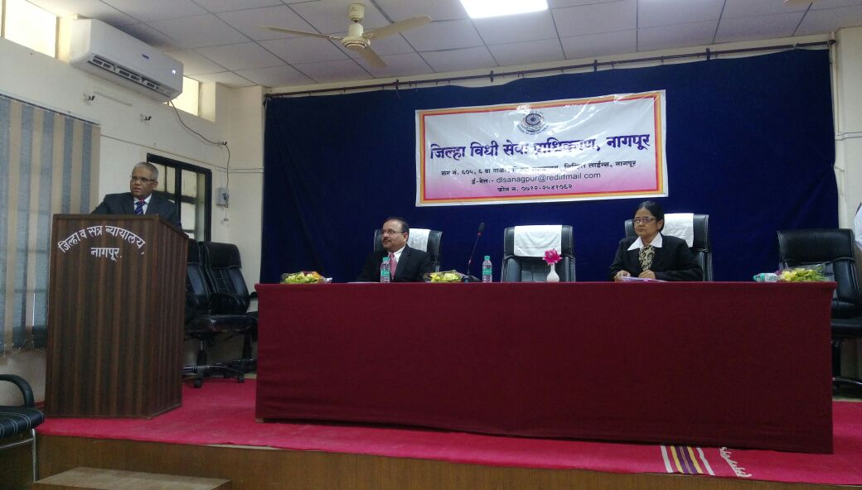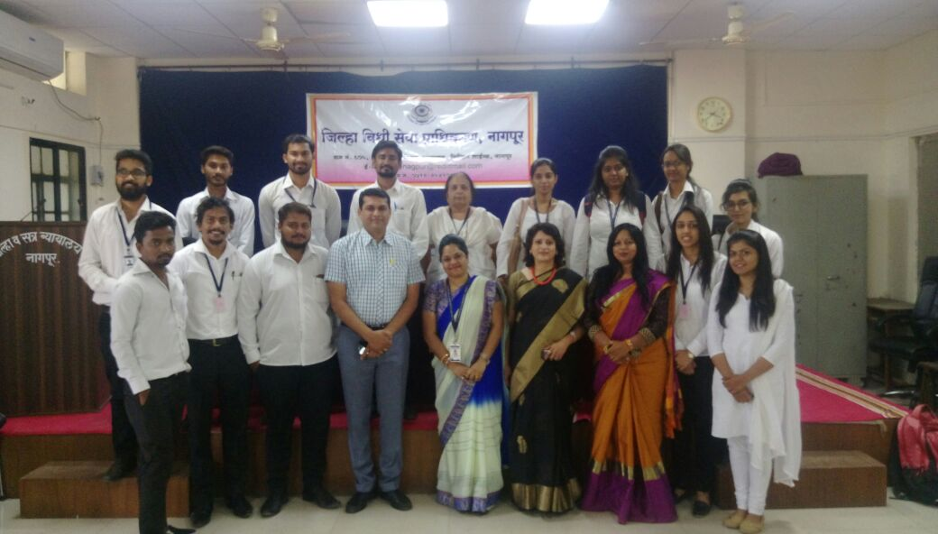
Dignitaries and students of dept. of Law during Awareness Programme at District Court

